Source Only VI Feature Functional Test
Revised: 12/14/2022 10:00 AM
TestStand Version: 2023 Q2
Author: Aman
Feature Spec:
Dependencies: Perforce
Test Category: [ Functional ]

Description
This feature in TS 2023 Q2 and allows the user to run the VIs in PPL. TS behind the scenes collates the VI’s and builds the PPL. An LV development system should be present for the PPL build to happen. This would enable the user to have better execution times.
This test needs to be done for both 32-Bit and 64-Bit LabVIEW and TestStand.
Preparation

- Install LabVIEW 2023 Q1 or later
- Install TestStand 2023 Q2 or later.
- Go to Labview Adapter setting. Configure -> Adapter -> Select Labview Adapter.
  - Ensure that LV RTE is selected.
  - Ensure option ‘Enable Build Distribution and Execute’ is enabled in Labview Adapter setting.
  - Ensure in Version drop-down, “Auto detect using VI version” is selected.
  - Restart TestStand if option ‘Enable Build Distribution and Execute was just enabled.
- As a starting point you may use media files from //TestStand/WebPages/TestCases/Adapters/LabVIEW/Media/SourceOnlyVI or you may create your own test VIs.
//../ -> Above path is represented as like this in this test plan from now onwards
- Location of all the generated PPL is C:\Users\<User>\AppData\Local\Temp\TestStand\NI_Builds\

Validation
Prevent Multiple TS instances to call LV Build APIs
- Close all instances of TS if they are open or any UI associated with TS
- Launch TestStand and run the sequence file - //../ProjectContext/LooseVIs/LooseVITesting.seq
- Open another instance of TS and run the same sequence. The subsequent instances should not be able to use the feature and run the source Vis directly. This will be obvious since there will be no build that happens before execution.
- Verify the option ‘Enable Build Distribution and Execute’ present in Adapter Configuration Dialog is disabled in all subsequent instances and the label just below the option says something like “Another Instance of TS is using the feature”
- Even when the first instance is closed the subsequent instances continue to have the feature disabled.
- Verify the option ‘Enable Build Distribution and Execute’ present in Adapter Configuration Dialog is still disabled in all subsequent instances and the label just below the option says something like “Another Instance of TS is using the feature”.
- Alternatively, you can use the sequence located at -> //../MultipleTS/CheckMultipleTS.seq to verify the error message.

Usage of project context to prevent cross builds
- Launch TestStand and open the sequence file //../ProjectContext/LooseVIs/LooseVITesting.seq. Do not click any step.
- Open the sequence file folder and open ‘InLV’ folder in explorer.
- Open the VI located there and make sure in the block diagram it sums to even numbers.
- Run the sequence file and ensure that the sum output is odd numbers
- This ensures that we always build in a project context so that same named VIs do not have cross linkage
- Try the above in various cases like class member calls, VI calls, inside and outside project. Some cases are present in the folder //../ProjectContext
- Note: We might need to disable verify prototype to verify these changes until re-use feature is done.

Verify directory and ppl name of ppl created by Teststand while building source only VIs
CASE 1 : Saved Sequence File
- Open //../ProjectContext/LooseVIs/LooseVITesting.seq and execute the sequence
- Verify the directory and PPL created has the same name as that of the sequence file which built it.

CASE 2 : Saved Sequence File + Increment Index Value
- Save the same sequence file under a different location.
- In the same instance of Teststand opened for previous case, open the sequence file from new location and execute the sequence file
- Since a directory with this sequence file name already exists under NI_Builds (Ex : LooseVITesting ), on the second attempt the directory name should be appended with an index value (Ex : LooseVITesting _1).
- The PPL built within should have the same name as the directory.
- Repeat the steps and verify if the index value keeps incrementing for sequences with same name.

CASE 3 : Unsaved Sequence File
- Open a new unsaved sequence file and configure it exactly like the file //./ForUnsavedSeqFile.seq.
- Execute the seq without saving it.
- Remember the ID that is shown message pop up and continue the execution.
- After execution validate that the directory and the PPL created has the name : “UnsavedSeqFileID_<ID>”. Here ID is from the message pop up.

Verify only one instance of TestStand can build source only vis
Only the first instance of Teststand can use the BuildAndExecute feature (to build source only VIs). The subsequent instances of TS cannot use the feature and hence cannot build any PPLs.
CASE 1 : First Instance of Teststand
- Open Teststand and enable BuildAndExecute feature.
- Open //../ProjectContext/LooseVIs/LooseVITesting.seq and execute it.
- Verify that NI_builds holding the outputs of previous execution is deleted.
- Verify if the PPL was built in the respective location.
CASE 2 : Subsequent Instances of Teststand
- With the first instance alive, open another TS instance in the similar manner as above (output directory should not get deleted this time)
- Open //../ProjectContext/LooseVIs/LooseVITesting.seq and execute it.
- Verify the even though the execution succeeds, no PPL is built in the destination directory.
- Repeat the above steps with multiple instances and ensure similar behaviour.

CASE 3 : Close First Instance
- With the setup at the end of Case2, close only the first instance while the remaining instances stay alive.
- Execute sequence from one of the instance and try to build a PPL in any of the opened TS instance.
- Ensure that no PPL is built.
- Now, open a new instance, the build directory should get deleted. Run the seq file and verify PPL is generated.

Verify Class Member Calls are executed without any Issue
- Open sequence file //./Test_Seq.seq. It has a label step named validating Class Member Call. Just after that a labview step is configured to call the VI using a class member call.
- Run the sequence and validate the seq execute without any error.

Verify TestStand and LabVIEW closes without leaks/error after execution
- After completing ‘Verify Class Member Calls are executed without any Issue’ section, close TestStand. Verify that no leaks or errors are seen.
- Now close LabVIEW and again verify no leaks or errors are seen.

Verify Changing LV instances between build cause no leaks/error
1. Verify the Build and execute feature is enabled.
2.Open the sequence file //./Test_Seq.seq and execute the sequence. Verify execution complete without any issue.
3. Once the execution complete, close the LV instance.
4. Now open //./ForUnsavedSeqFile.seq and now execute the sequence again. Verify a new instance of LV is launched.
5. Verify execution complete without any issue.
6. Now Close the TestStand and verify no leaks or errors are seen. After this close the LV and verify no leaks or errors are seen.
7. Open //./Test_Seq.seq again and execute the sequence file. Verify execution completes.
8. Unload all modules and executes again. Verify execution completes.
9. Unload all modules again and then shutdown LV.
10. Executes seq again and verify execution completes.
11. Now close the TS and verify no leaks or errors are seen.

Verify Debugging Option is honored while creating PPL
- Verify option “Enable Debugging and Tracing” in adapter configuration dialog is enabled. If it is just enabled restart the TS once.
- Open //./VIs with Breakpoints/Test_Seq For breakpoint.
- Execute the seq once.
- Open LabVIEW and then go to “ Operate -> Debug Application or Shared Library Configure”. Select Seqedit.exe from the drop down and connect to it. If you are debugging a VI in project context, choose SeqEdit.exe - <projectname> in the drop down. You can only debug Vis in one LV context at a time (either default context or a specific project context).
- Run the sequence again and validate we hit the breakpoint. Once breakpoint is hit, click on “Retain Wire Value” ( By default it is set to false ) then continue. When execution again stops validate the wire value by hovering over them. Validate these values with your inputs in the seq file.
- Now go to adapter configuration and disable the option “Enable Debugging and Tracing”. Restart the Teststand and execute sequence file.
- Open LabVIEW and then go to “ Operate -> Debug Application or Shared Library Configure”. Verify that nothing is listed in the dropdown.
- Run the sequence and validate that the breakpoint is not hit.

Verify Step into for LV RTE with Vis having Allow Debugging enabled.
- Disable the Build and Execute option from the LabView Adapter Configuration and Enable Debugging and Tracing option. Restart TestStand.
- Open //. / VIs with Debugging Enabled Setting/Test_Seq for debugging enabled.seq.

- Execute the seq once.
- Put a breakpoint to all the LV action steps and save the seq.
- Open LabVIEW and then go to “ Operate -> Debug Application or Shared Library Configure”. Select Seqedit.exe from the drop down and connect to it. If you are debugging a VI in project context, choose SeqEdit.exe - <projectname> in the drop down. You can only debug Vis in one LV context at a time (either default context or a specific project context).
- Run the sequence again and verify you can step into the Vis. Also Validate the wire retain their values, you can do so by hovering over the wires.
- Now enable Build and Execute in LabView Adapter Configuration. Restart the TS.
- Redo from step 2 to 6 and validate it works in same way.

Verify Step into for LV RTE with Vis having Allow Debugging disabled.
- Disable the Build and Execute option from the LabView Adapter Configuration and Enable Debugging and Tracing option. Restart TestStand.
- Open //. / VIs with Debugging Disabled Setting/Test_Seq for Debugging Disabled.seq.
- Execute the seq once.
- Put a breakpoint to all the LV action steps and save the seq.
- Open LabVIEW and then go to “ Operate -> Debug Application or Shared Library Configure”. Select Seqedit.exe from the drop down and connect to it. If you are debugging a VI in project context, choose SeqEdit.exe - <projectname> in the drop down. You can only debug Vis in one LV context at a time (either default context or a specific project context).
- Run the sequence again.
- Verify you cannot step into the Vis. This just shows the panel briefly and immediately returns.
- Now enable Build and Execute is in Labview Adapter Configuration. Restart the TS.
- Redo from step 2 to 6 and verify you can step into the Vis now.
The PPLs are built with debugging enabled because “Enable Debugging and Tracing” option is enabled. So, even though the Vis were not set to allow debugging, when built into PPL, this setting gets enabled for those Vis.

Verify Step into for LV UI in LV
- Do the Step Into scenarios above when LV adapter is set to Dev mode.
  - Validate in case of step into, we step into the VI and LabVIEW opens up both diagrams.

Verify Edit time APIs work when the feature is enabled
- Open the computer motherboard example for LV
- Make sure Build n Execute feature is enabled
- Verify the following by clicking the buttons
  - Edit Project
  - Create project
  - Edit VI
  - Create VI
  - Add or Remove Vis from Project
  - Select Express VI
  - Convert Express VI to Standard VI
  - Configure settings for property node
  - Convert Property Node to Standard VI
  - Override code module
    - This would be disabled with the below reason
    - 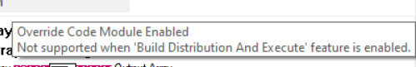
- Basically, all the operations which were possible with LV dev system and not possible with RTE should now be working fine with Build & Execute feature with RTE
- Play with all the 3 types of call, VI, Class Member, Property node
- Make sure that VI description is nonempty text for a VI with given help description

Test Supported and Unsupported LV versions

Case 1: Feature is disabled when unsupported LV version is active at the time of TestStand launch
- Close TestStand and LV, if any.
- Activate unsupported LV version.
- Launch TestStand.
- Verify that the control for Build & Execute feature is greyed out in adapter configuration dialog, when RTE is selected.
- Verify that executing sequence file does not create any PPLs as part of Build & Execute, thereby verifying that the feature is not used.
- Close LV and activate supported LV version.
- Verify that the control for Build & Execute feature is greyed out in adapter configuration dialog, when RTE is selected.
- Verify that executing sequence file does not create any PPLs as part of Build & Execute, thereby verifying that the feature is not used.

Case 2: Feature is always enabled when supported LV version is active at the time of TestStand launch
- Close TestStand and LV, if any.
- Activate supported LV version.
- Launch TestStand.
- Verify that the control for Build & Execute feature is not greyed out in adapter configuration dialog, when RTE is selected.
- Close LV and activate unsupported LV version.
- Verify that the control for Build & Execute feature is not greyed out in adapter configuration dialog, when RTE is selected. Ensure the feature is enabled.
- Execute LabVIEW version of computer motherboad test example
- Verify that execution does not happen and there will be an error shown for the unsupported version of LV.
- Close LV and activate supported LV version.
- Execute LabVIEW version of computer motherboad test example
- Verify the execution succeeds and it creates a PPL as part of Build & Execute, thereby verifying that the feature is used.

Verify TestStand throws error messages for invalid/broken scenarios
- Open Error.seq from TestCases\Adapters\LabVIEW\Media\SourceOnlyVI\ErrorCases folder
- Run the MainSequence
- You should see a load error ‘The dependent file(s) 'Comparison_....vi' are a source-only component and its compiled code is not found in the compiled object cache.’ in the first step.
- Delete this step, save sequence file.
- Repeat steps [2-4] for all the steps until step ‘PPL in memory’.
- For ‘PPL in memory’ step, open Error.lvlibp from media and then execute the sequence. It should give build error as it cannot create Error.lvlibp when its already in memory.
- Now delete all the steps until “8 a. Show Build Log File Path in Error Dialog - Create Distribution” step and save the sequence. Close PPL opened in LabVIEW.
- Run the MainSequence and validate you see build error saying “ An error occurred while building PPL. LabVIEW returned with the following error: <ErrorMessage>". Also the error dialog contain information saying something like “Detailed Build Log: <Build Log Path>”.
- Error from RebuildDistribution vi.
  - Delete all the step until “9 a. Show Build Log File Path in Error Dialog - Rebuild Distribution” and save the sequence.
  - Clear cache for sequence file.
  - Run the MainSequence and validate the build complete without any issue.
  - Now Open “//./ErrorCases\To Validate Build Log File Path in Error Dialog\Folder 2\Same Name VI.vi” and break it and save it. For example, you can delete one of the input wire to break.
  - Re-Run the sequence and validate the build error out and error is thrown. Validate the Detailed Build Log path is also given in error dialog, it is in the lower end of the error dialog.
- Verify case “Closing LabVIEW when performing build”. Open //./Test_Seq.seq. Run the sequence and once the dialog appear that says “Building Modules..”, close the LabVIEW application using the task manager. Validate error dialog appears.
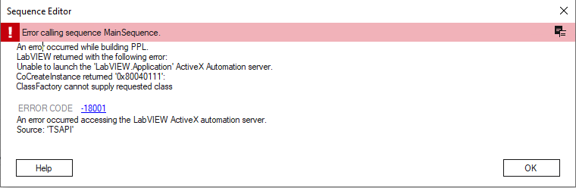

Verify progress dialog while Building PPLs
- Open attached test sequence file “BuildPPL_Test.seq”.
- Execute using “Run Mainsequence” and observe the preload dialog box.
- Notice that after Preloading completes the dialog’s title changes from “Preloading modules…” to “Building PPLs…” to indicate PPLs are being generated for source only VIs.
- Along with this, only Sequence File information is displayed while Sequence, Step, Module and Module Path values are set to null.

Verify prototype/namespace change results in correct behavior.
Case1 (Rebuild PPL when VI logic changes)
- Open VerifyPrototypeForBuild.seq
- Execute it with ‘Build and Execute’ feature enabled. Both steps should have passed.
- Now go to step ‘Calling VI in PC’ and click ‘Edit VI’ button.
- Change the VI logic (Multiply instead of addition) and close it.
- Change the ‘Limits’ for this step to Locals.ExpectedOutputForMultiply and execute.
- It should do a rebuild now since no prototype/namespace has changed.
- Both the steps should still have passed status which means rebuild pulled the updated VI.
- Note: You can verify by looking at the time stamps of projects in %temp%\NI_Builds\<sequencefilename>\BuildProjects folder. For rebuild, the project files here will not be updated.

Case2 (Rebuild PPL – Prototype Change)
- Open VerifyPrototypeForBuild.seq and execute it.
- Open Media\SourceOnlyVI\VerifyPrototype\VIinProjectandLibrary\VI in Project.vi in LabVIEW app and change its prototype (add a new input terminal and connect it to connector pane)
- Execute sequence file. Verify PPLs are not rebuilt and sequence file executes without error.
Note: Executes with Vis in memory.
- On step ‘Calling LooseVI’, click edit VI (this is to ensure Teststand unloads that module triggering a rebuild on next execution).
- Close the VI and execute again.
- You should see an error saying VI prototype has changed. Refer the screenshot below.
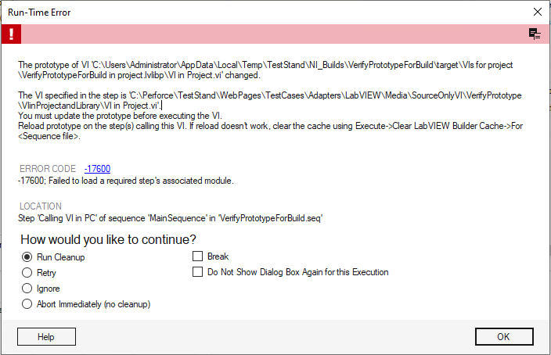
NOTE : Ensure line 'The VI specified in the step ....' is present in the error dialog.

- Click OK -> Navigate to the step causing the error and select ‘Reload Prototype’.
- Execute the sequence which would further trigger a full build and execution finishes without errors.

Case3 (Rebuild PPL – Namespace Change)
- Open VerifyPrototypeForBuild.seq and Run MainSequence to generate a PPL.
- Open VIinProjectandLibrary\Project.lvproj in Labview and create a library. Add ‘VI in Project.vi’ within the library. Save VI, library and project.
- Go back to Teststand and navigate to ‘Calling LooseVI’ step -> Edit VI -> close the VI without any modifications.
- Execute the sequence.
- It should display a namespace error as follows :
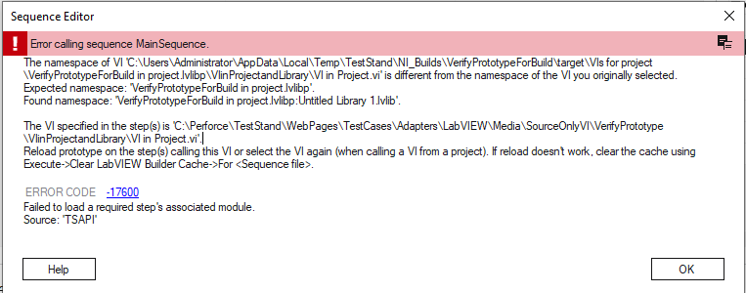

- Click OK, navigate to the first step. Re-configure the VI.
- Execute the sequence and ensure a full build. Sequence file executes without errors.

Case4 (Full build PPL – Prototype Change)
- Resync files, Open VerifyPrototypeForBuild.seq and execute it.
- In LabVIEW app, open ‘VI in Project.vi’ and modify its prototype (eg: connect new terminals in connector pane.)
- Navigate back to TS, select ‘Calling LooseVI’ step and configure it to call a different VI.
- Execute the sequence. An error pops up mentioning that the prototype has been modified. Also verify that a full build happened.
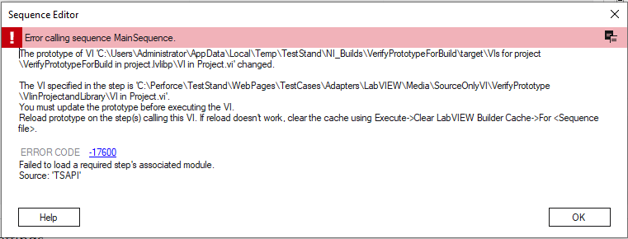
- Reload prototype for that step and execute again for a full build. Sequence file executes without errors.

Case5 (Full build PPL – Namespace Change)
- Resync files and Open VerifyPrototypeForBuild.seq and execute it.
- In LabVIEW app, open the project Media\SourceOnlyVI\VerifyPrototype\VIinProjectandLibrary\Project.lvproj and move the VI (VI in Project.vi) into the library (this changes its namespace).
- In TestStand, modify step ‘Calling LooseVI‘ to use Media\SourceOnlyVI\VerifyPrototype\LooseVIs\VI2.vi instead of VI1.vi.
- Save the sequence.
- Execute it again ensure full build.
- You should see an error saying VI namespace has changed. Refer to the image below.

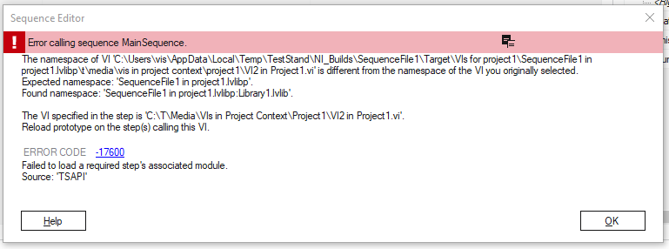
NOTE : Ensure line 'The VI specified in the step ....' is present in the error dialog.

- Click OK -> Navigate to the step causing the error and manually select the VI from the new location.
- Execute the sequence which would further trigger a full build.

[Skip – Issue not seen with LV 2023 Q3] Case6 (Namespace increase/decrease cases error due to Labview optimization)
If a PPL includes only two VIs both of which are within the same library then Labview by default optimizes the VI namespace by omitting <LibraryName> and saves the VI directly under the PPL. Hence, there are ambiguities when the namespace of such VI is changed.

[Skip – Issue not seen with LV 2023 Q3] Namespace Increases (Rebuild) :
- Open sequence file “Namespace Test.seq” which invokes two VIs within same library.
- After first build ensure that the PPL contains the VI directly and not under a library.
- Now open the library in LV, right click on “VI2 in library.vi” and select ‘Remove from library’ and save all.
- Navigate back to TS and select first step and click on ‘Edit VI’ and execute the sequence.
- You will encounter an error stating ‘Namespace changed for the first VI’ which is incorrect since no change was made to the first VI.
- This occurs since Labview now adds the library name in the first VI’s namespace to distinguish between the two VIs within PPL.
- To resolve the error, select Execute tab -> Clear LabVIEW Builder Cache -> For <Sequence file> and rerun.

[Skip – Issue not seen with LV 2023 Q3] Namespace Decreases (Rebuild) :
- Resolve the error in previous scenario by reloading prototype.
- The next execution triggers a full build.
- Further, open the library in Labview and add the second VI back into the library.
- Navigate back to TS and edit VI for first step.
- Execute the sequence, you will encounter the same error as before but this time since the namespace has decreased due to optimization.
- This triggers an error in first VI even when the user has made no modification for it.
- To resolve the error, select Execute tab -> Clear LabVIEW Builder Cache -> For <Sequence file> and rerun.

[Skip – Issue not seen with LV 2023 Q3] Namespace Increases (Fullbuild) :
- Open sequence file “Namespace Test.seq” which invokes two VIs within same library.
- After first build ensure that the PPL contains the VI directly and not under a library.
- Now open the library in LV, right click on “VI2 in library.vi” and select ‘Remove from library’ and save all.
- Navigate back to TS and select second step and select ‘Reload Prototype’ to update the changes.
- Execute sequence file. You will encounter an error stating ‘Namespace changed for the first VI’ which is incorrect since no change was made to the first VI.
- This occurs since Labview now adds the library name in the first VI’s namespace to distinguish between the two VIs within PPL.
- To resolve the error, select Execute tab -> Clear LabVIEW Builder Cache -> For <Sequence file> and rerun.

[Skip – Issue not seen with LV 2023 Q3] Namespace Decreases (Fullbuild) :
- Resolve the error in previous scenario by reloading prototype.
- The next execution triggers a full build.
- Further, open the library in Labview and add the second VI back into the library.
- Navigate back to TS and select second step and select ‘Reload Prototype’ to update the changes.
- Execute the sequence, you will encounter the same error as before but this time since the namespace has decreased due to optimization.
- This triggers an error in first VI even when the user has made no modification for it.
- To resolve the error, select Execute tab -> Clear LabVIEW Builder Cache -> For <Sequence file> and rerun.

Verify Reuse Workflow :
Required Media for this section is saved under :
//TestStand/WebPages/TestCases/Adapters/LabVIEW/Media/SourceOnlyVI/Reuse TestCases/

First Build Case :

- Open the sequence file “Build.seq” and enable BuildAndExecute feature under LV adapter config.
- This sequence contains calls to a LooseVI, class member VI, VI within a project and Class member VI within a project.
- Execute the sequence using “Run MainSequence”. Notice PPL gets built during preload stage and would require around 1-2mins.
- The build output will get saved under : C:\Users\<User>\AppData\Local\Temp\TestStand\NI_Builds\
- Note timestamp of PPL and wait one minute before moving to next section.

No Build Case : [No modification to VI or Sequence file]

- After the completion of first build, in the same instance of Teststand unload all modules.
- Re-run the Build.seq using “Run MainSequence”
- Ensure the execution time is significantly less (couple of seconds) (i.e) it validates the built module cache already exists and does not rebuild the PPL.
- Hence, verify the PPL under NI_Builds/ has the timestamp of the first build time and all steps in the sequence pass.

No Build Case : [Non-LV modification]

- In the same instance of TS with Build.seq opened, duplicate “Test” step (last step of the sequence) and unload all modules.
- Run MainSequence.
- Notice the build time is insignificant and that the PPL has not been modified since a non-LV change does not trigger a rebuild.

NOTE : TEST ALL THE FOLLOWING CASES AFTER FIRST BUILD AND IN THE SAME INSTANCE OF TESTSTAND.
Rebuild Case : [LV module modification]

- Navigate to “Build Loose VI” step.
- Under step settings, select Edit VI option (will unload this module) to open the VI.
- Change the default values to x=10, y=7.
- Right click on controls, under Data Operations, select ‘Make Current Values Default’. Save and close the VI.
- Run MainSequence.
- While preloading, it will detect that the unloaded VI has been modified and will rebuild “Build.lvlibp”.
- This time, the ‘Build Loose VI’ step will fail since the VI in the PPL has been updated and will generate a different output than the expected value.
- Verify the modified VI is present in the new PPL.

Rebuild Case : [LV module modification]

- Unload all modules and minimize.
- Launch Labview and open block diagram of LooseVI.vi and remove the increment operator and reconnect wires.
- Save the VI and close Labview.
- Open the minimized instance of TS with Build.seq and “Run MainSequene”
- Notice that Build.lvlibp gets rebuilt and hence the output of the new VI will not match the expected value which was set for the old VI.
- NOTE : “Build in project.lvlibp” does not get rebuilt.

Full Build Case : [New LV step insertion]

- Launch TS with BuildAndExecute feature enabled and open “Build.seq”.
- Build the PPL for the first time and note the timestamp of the built PPL under NI_Builds folder.
- After the execution, add a new LV step, configure it to call Fbloosevi.vi from set 2 folder.(replicate “Full Build Loose VI” step from FullBuild.seq).
- Run MainSequence, will trigger a full build.
- Ensure PPL timestamp has got updated, open the PPL and verify the new VI has been added.

Full Build Case : [Modify existing LV step – modifying path]

In Build.seq relocate the Vis from its original location and ensure full build happens when you update the path for : modify path of one step at a time and execute. Use Vis from set2\path changes
- LooseVI.vi in “Build Loose VI” step.
- Class.lvclass in “Build Class VI” step.
- Project.lvproj in “Build Loose VI in Project” step.
- ProjectClass.lvclass in “Build Class VI in Project” step.
  - Namespace error is thrown.
  - clear cache and execute again. Error should not be shown now.

Rebuild Case : [Modify existing LV step – modifying VI call type]

- In “Build.seq” select first step. Open step settings panel and set Call Type from ‘VI Call’ to ‘Class Member Call’.
- Select ClassVI.vi from under Class.lvclass and save the sequence.
- On execution ensure it’s a rebuild.
- Similarly change the call type from ‘Class Member Call ‘ to ‘VI Call’ and modify step accordingly.
- Repeat the above steps and verify rebuild.

Full Build Case : [Express VI to Standard VI]

- Add an LV action step and configure it to call any express VI.
- Run the sequence and verify that the first build does not have the Express VI included.
- Navigate back to Teststand and select “Convert ExpressVI to StandardVI” option for this step.
- Execute the sequence now and verify PPL contains the new VI.

Full Build Case : [Create or Edit Project]

- Select any LV step which had VI selected from within a project.
- Click on “Edit Project” icon and add a new empty VI within this project. Save the project.
- Configure the step to call the new empty VI from project context.
- Re-run the sequence file and ensure builds a new PPL with the empty VI.
- Again select any LV step which had VI selected from within a project.
- Click on create new project (overrides the existing project) in the same location and insert VI or classes as per your choice and save the project.
- Configure the step to call the new project and vi.
- Re-run sequence and verify changes in the PPL.

Full Build Case : [Dynamic Dispatch Template of VI]

- Open SourceOnlyVI\ClassMember\Class_Override.seq.
- Build the PPL and ensure only Class2 is included.
- Before the next execution, navigate to the second step and change the Class under step settings to Class1 (do not update test.vi path)
- In the next execution, ensure a full build and that both Class1 and Class2 have been added into the PPL.

Multi steps case :

- Have 3 steps configured with 2 steps pointing to same VI. lets say A.vi, B.vi with 2 steps referring to A.vi
- Execute the sequence.
- Make sure the generated PPL contains both Vis.
- Now change one of the steps referring to A.vi to B.vi.
- Run the sequence.
- PPL should still contain both Vis.
- Now change the remaining step pointing to A.vi to B.vi
- Run the sequence.
- The PPL should still contain A.vi.
- ExecuteClear LabVIEW Builder Cache<Sequence File> or <globally>
- Run the sequence.
- PPL should only contain B.vi
- Repeat the same with Vis called from project context. (both projects have Vis of same names.)
  - Instead of two PPLs, only one PPL should be present when built after clearing cache.

Undo/Redo :

- Configure a step with A VI
- Run the sequence
- Now change A VI to B VI, then C VI
- Hit undo until the step points back to A VI.
- Run the sequence
- Make sure that the PPL is not updated.
- Repeat the same for class member call type by changing class path and member vis

Substep :

- Configure a VI with substeps
- Run the sequence
- Make sure the built PPL does not contain the VI referred in the sub steps.

New TS instance [Always a full build] :

- After performing the first build do not modify any step of VI’s logic.
- Shutdown and relaunch TS.
- Open the same sequence file and execute, ensure it always results in a full build and the old PPL under NI_Builds get deleted before the new one gets created.

Clear builder cache :
- Configure two LV steps in a sequence file and execute them.
- Go to NIBuilds folder in %temp%/TestStand and in targets folder open the PPL to ensure that both the VIs are present in the PPL.
- Delete/skip 1 of the step in the sequence file.
- Execute the sequence again and verify that the PPL still contains both the VIs.
- Now Clear the builder cache for this sequence file and execute again.
- Verify that the PPL contains only 1 VI.
- Repeat the above operations for more than 1 sequence file and clear the builder cache globally and ensure that the PPL contents do not contain skipped/deleted VIs

Reuse with sequence call steps

- Open SourceOnlyVI\Reuse TestCases\Reuse in callee sequence files\Main.seq and execute it.
- Verify that PPLs are created for Main, 4.seq and 6.seq where 4 and 6 are called from Main through sequence call steps.
- Open SourceOnlyVI\Reuse TestCases\Reuse in callee sequence files\5.vi and change the value in the string constant. Also open 3.vi, update the default value of x and save the VI.
- Execute Main.seq again and verify that the PPLs for 4 and 6 get rebuilt and the steps that call 3.vi and 5.vi now fail.
- Now add new steps into 4.seq and 6.seq and configure them to call some new Vis.
- Execute Main.seq again and verify that now a full build happens for both 4.seq and 6.seq.

Property Node

- Open SourceOnlyVI\PropertyNode\ BuildAndExecute_PropertyNodeCalls.seq and execute it.
- Verify that PPL is created for both steps.
- Ensure that the PPL contains the classes and the VI contains the property.

Interactive Executions

- Open SourceOnlyVI\PropertyNode\ BuildAndExecute_PropertyNodeCalls.seq
- Add non-LV steps like python
- Select any LV step and right click - execute for interactive execution.
- The step should execute successfully and all LV step VI’s should be present in the PPL
- Note that all LV step VI would be present in the PPL even if they were not selected.

Temp LV Project Save Dialog

- Open SourceOnlyVI\PropertyNode\ BuildAndExecute_PropertyNodeCalls.seq and execute it.
- Now Close LV and LV should prompt for saving unsaved changes. Hit save.
- Close TS
- Repeat step 1 and it should run successfully.
- Intention is that changes to the temp project should not affect TS

Build Log is locked.

- Open SourceOnlyVI\PropertyNode\ BuildAndExecute_PropertyNodeCalls.seq and execute it.
- Go to the build folder and open the corresponding build log.txt
- Keeping the text file open, add a new LV step.
- Configure any VI in the new step
- Run the sequence again.
- It should execute successfully, and the PPL should contain the new VI

Verify Build Output Deletion :

Required Media for this section is saved under :
//TestStand/WebPages/TestCases/Adapters/LabVIEW/Media/SourceOnlyVI/Build Output Deletion/

Case 1 : BuildLog.txt is open in another application

- Launch TestStand and enable “BuildAndExecute” feature.
- Open TestSeq.seq from the test media and select “Run MainSequence”.
- Open BuildLog.txt in notepad : “C:\Users\<Username>\AppData\Local\Temp\TestStand\NI_Builds\TestSeq\target\BuildLog.txt”
- Return to Teststand and unskip step = “Test VI - DLL Dependency” and Run MainSequence.
- Ensure no error dialog is thrown and that the new BuilLog.txt under NI_Builds (and not the opened document) has correct data.
- Also ensure that the execution completes successfully and the PPL is built in the required location.

Case 2 : PPL has DLL Dependency

- After the above run completes, check if the “NI_Builds\TestSeq\target” folder contains MultiplyDLL.dll
- Return to TS and unskip step = “Multiply VI” -> Run MainSequence.
- Ensure the following error pops up :
“You can clear the cache for the sequence file from Execute->Clear LabVIEW Builder Cache->For <Sequence file name>”
- Click “OK” on the error dialog and follow the mentioned steps to clear cache.
- Re-run MainSequence and check no errors are thrown and the new PPL is successfully built under NI_Builds folder.
  - PPLs will be created in <SequenceFileName>_1 folder. This is because there is a dll in the output folder LabVIEW can’t delete because it is loaded in TestStands memory.

- National Instruments Confidential
Copyright © 2014 National Instruments Corporation

